

SIT123-Responsive Web Applications.

Assignment 3. Work Report.

By

Thisara Kumara - BSCP-CS-42-080

PROJECT SUMMARY

The application I created is a Movie app. in which you can register to get details of any movie available online. including new releases. The goal of this app is to make it easier for anyone to get access to details of multiple with the minimum effort used.

This service is based on a single website, so as a user you would not have to use up time to search for one movie at a time and visit a separate website for each movie. With Vue Movies you any movie you want to get details of is only one click away.

FUNCTIONS OF THE SYSTEM.

At first There is a registration process, which is very simple.

Once you’ve registered you will be directed straight to the search section, where you can search for any movie available.

The moment you’ve searched for a movie you will get details of multiple movies that have the same name, with details such as the date or origin, cast etc.

In this vue-JS based application there are 2 major components.

Login/Register page.

Home/Movie detail page

The login/register component requires the user to either register before getting access or login with their credentials if they have registered in the past.

The home page consists of the search tab to access any movie that is registered in the IMDB data base.

IIMPLEMENTATION OF THE CODING AND OTHERS.

What did I use?

For the login/register Vue I used Firebase and vuex.

Vuex is a state management pattern + library for Vue.js applications. It serves as a centralized store for all the components in an application, with rules ensuring that the state can only be mutated in a predictable fashion.

Firebase is a Google-backed application that provides tools for tracking analytics, reporting and fixing app crashes, creating marketing and product experiment. In this case I used the firebase for the back-end of my register and login authentication.

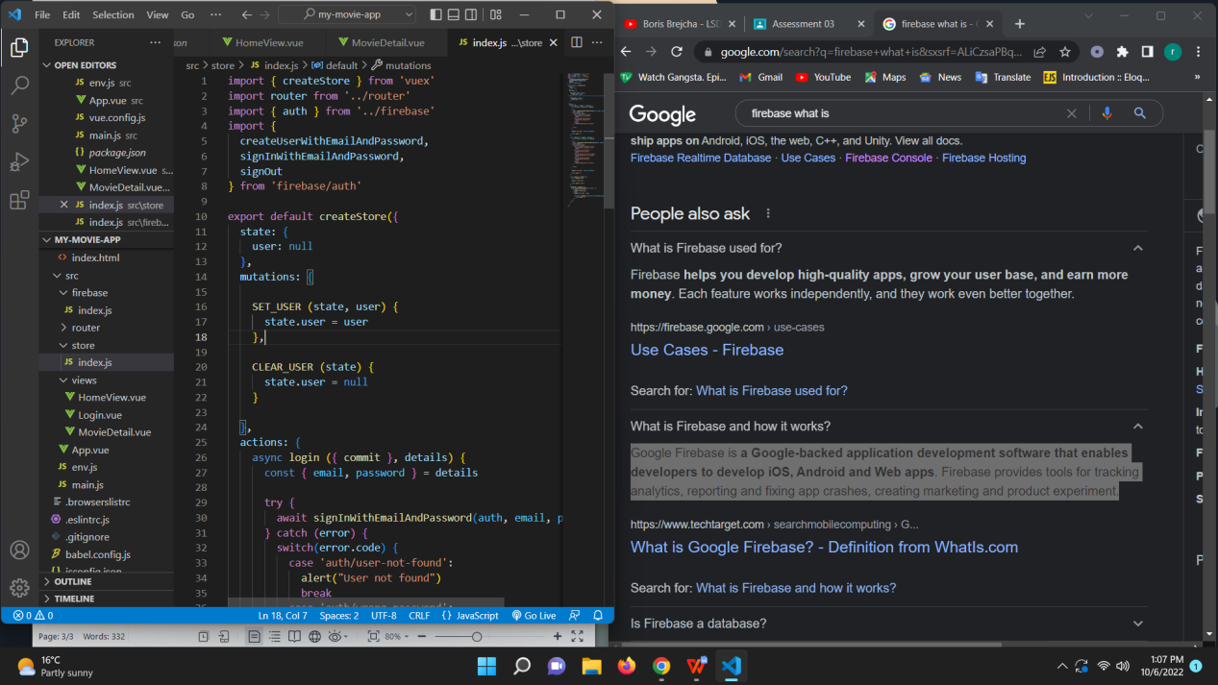

Mentioned above is the JS of the vue.store.

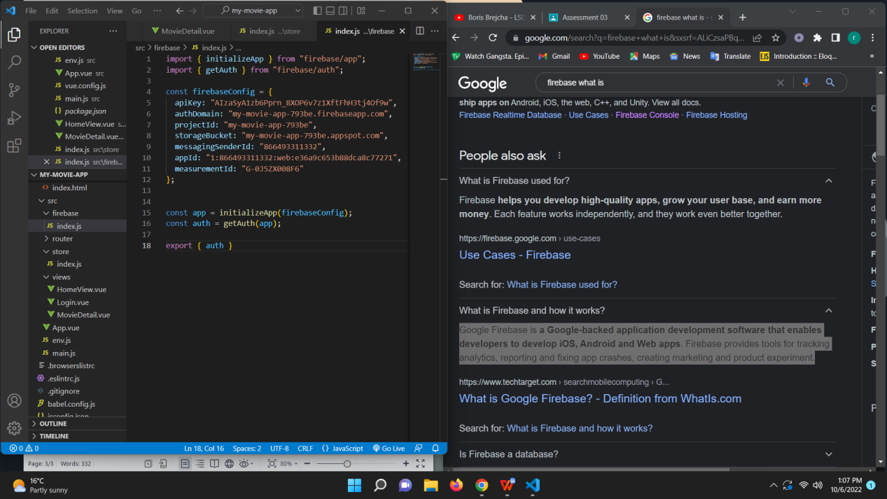

Here lies the imports necessary for FIrebase components.

The Home/Movie details views were made in separate Vue JS pages.

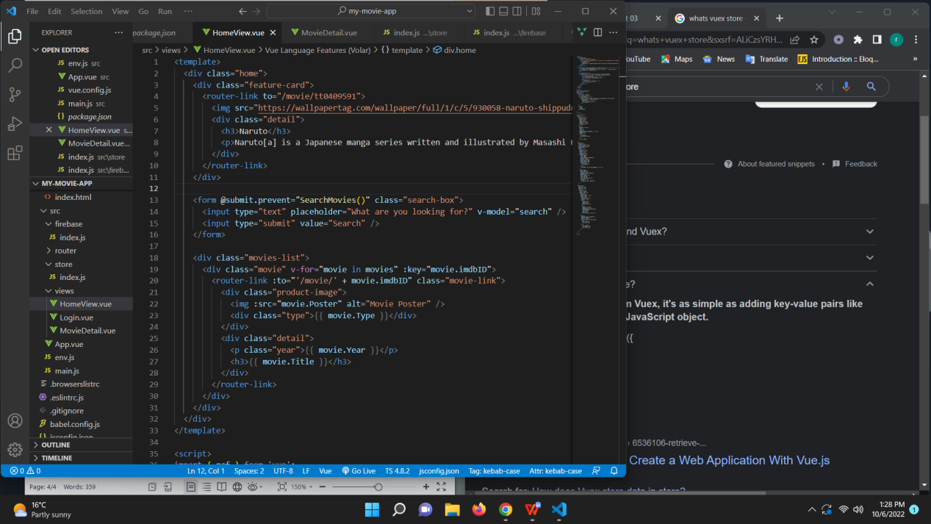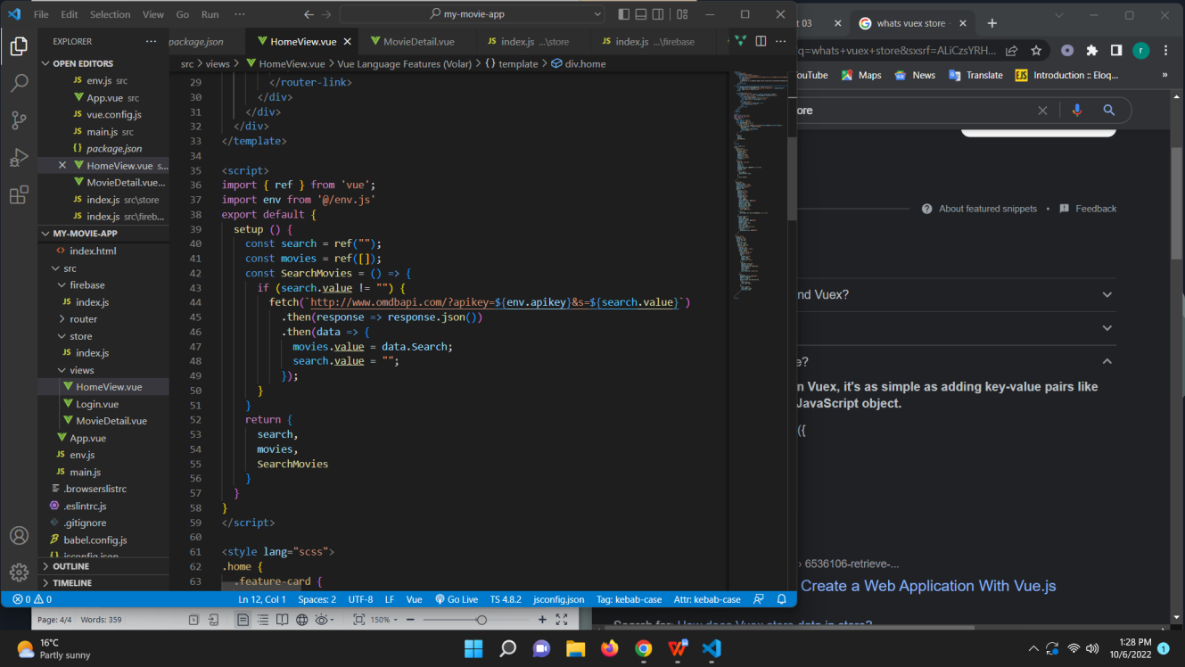

The Home vue consisted of the following forms and buttons to add the API key

That I aquired from the OMDB database. As you can see I’ve imported env from

Env.js , which is the JS file I made to store my API key.

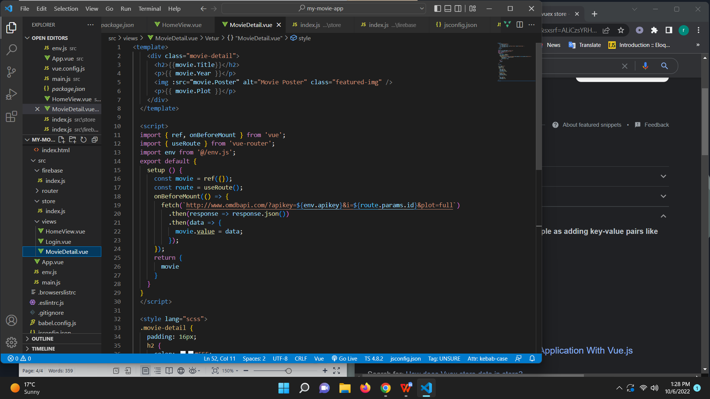

Using the router to fetch the API key from the JS file and adding to the button.

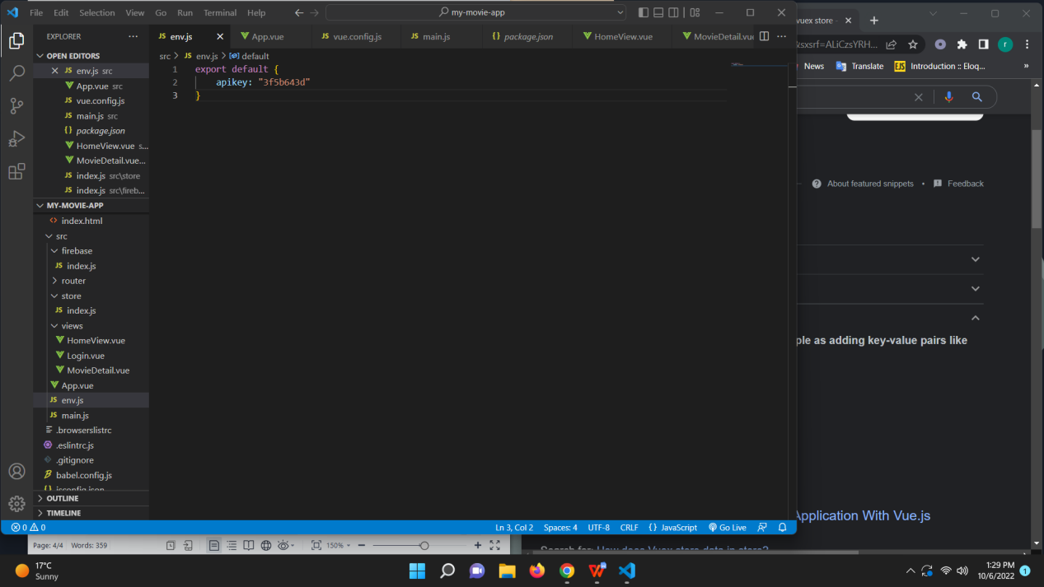

This is the API key that was stored in the JS file. This key gave access to all the movies

Available in the IMDB database.

One of the most important, powerful yet very simple to use applications is Vue Router.

What the vue router basically does is acting as the official navigation panel for all the Vue apps

That is used in a web app.

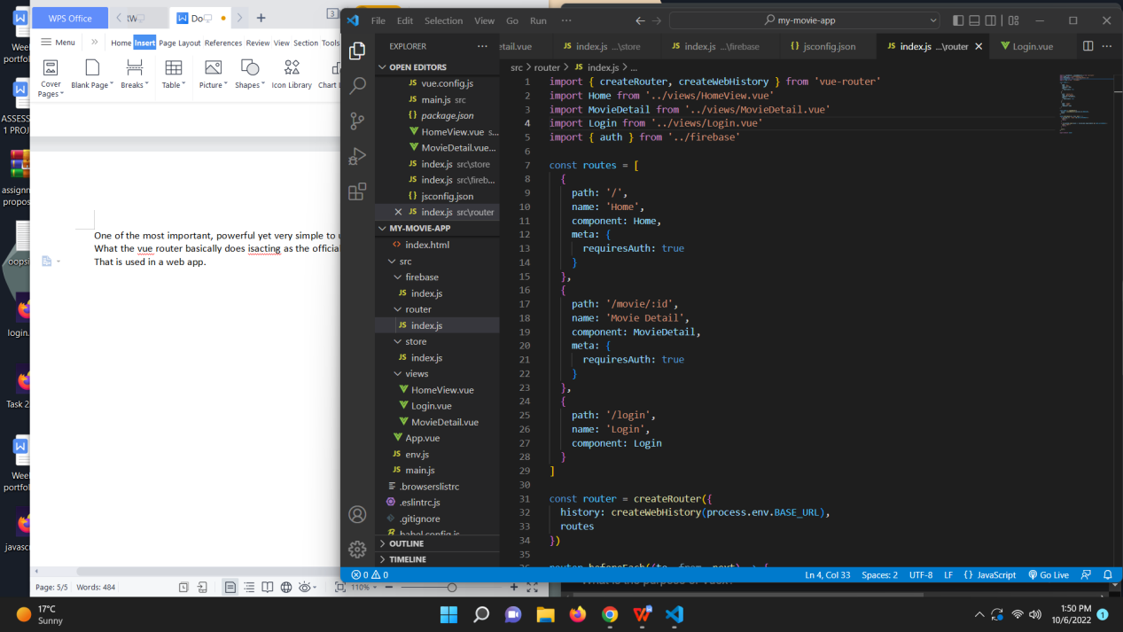 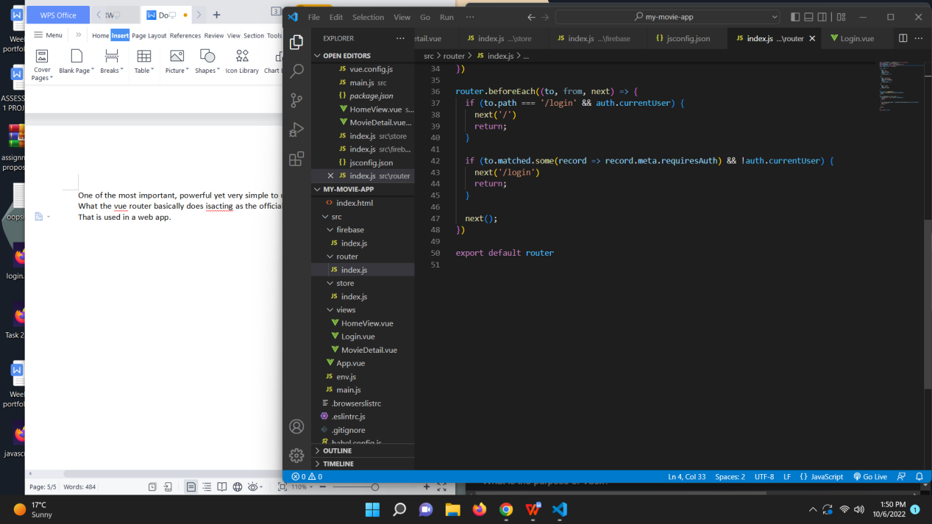

This is the router component and as you can see on the top , all the imports and the routes and which

Paths required Authentication (logging in) prior.

Github link : https://github.com/river080/SIT120-RWA-assignments/tree/main/Assignment%203